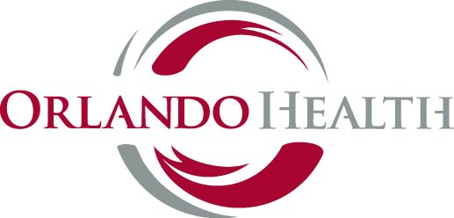

Orlando Health Pharmacy Residents 2017-2018
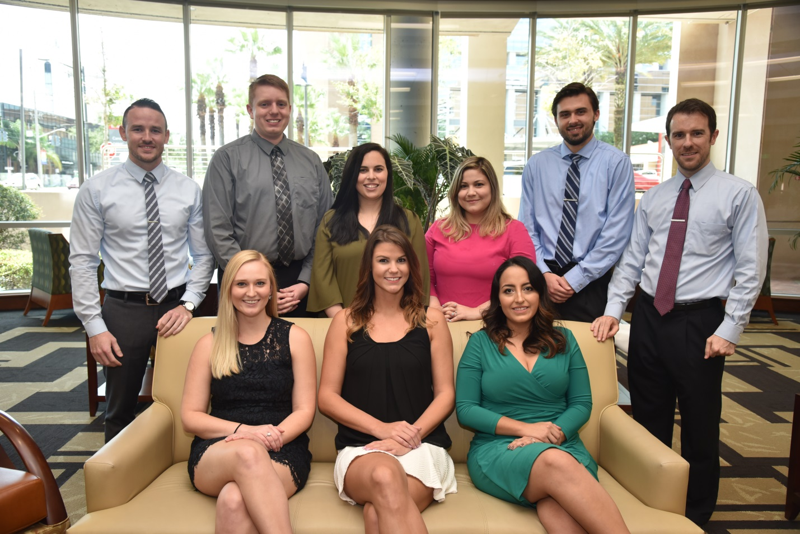
Top: Dominick Curry, Andrew Schwartz, Haley Giron, Natalie Grunwald, James Breslin, Jesse Unum
Bottom: Bailey Constantine, Becca Toor, Laura Robaya

PGY-1 Pharmacy Practice Residents

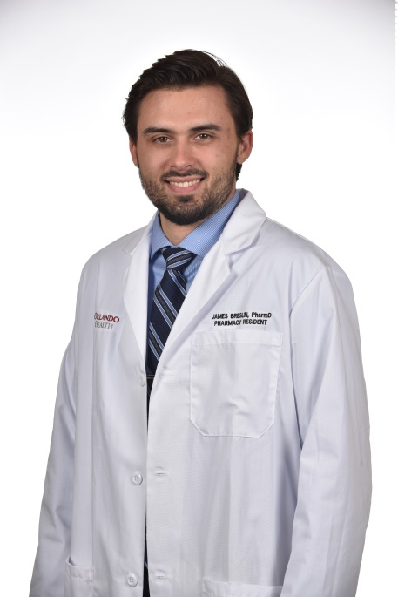
James Breslin, Pharm.D.
Dr. James Breslin, born and raised in Titusville, FL, received his Doctor of Pharmacy from the University of Florida College of Pharmacy’s Orlando Campus in 2016. As a PGY-1 pharmacy resident at Orlando Health, Dr. Breslin will participate in patient-care rounds and monthly code coverage. He will present a continuing education seminar on the role of probiotics, perform a medication use evaluation on sugammadex, as well as conduct a research project evaluating the treatment duration of urinary tract infections in patients with spinal cord injury. Following the completion of his residency, he plans to pursue a PGY-2 pharmacy residency and a career in clinical pharmacy with a focus in critical care or emergency medicine.

Email: James.Breslin@orlandohealth.com
Laura Robayo, Pharm.D.
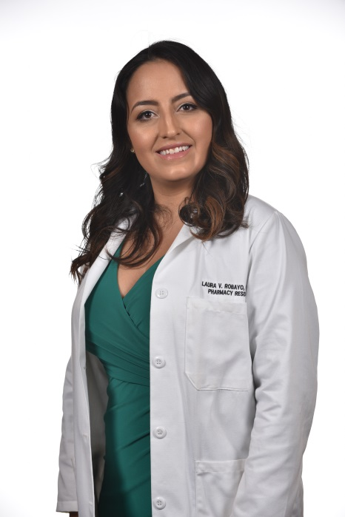
Dr. Laura Robayo, originally from Boca Raton, FL, received her Doctor of Pharmacy degree from the University of Florida in 2017. As a PGY-1 pharmacy resident at Orlando Health, Dr. Robayo will participate in patient-care rounds and monthly code coverage. She will also complete a research project identifying a process for pharmacist-driven discharge medication reconciliation and counseling. In addition, she will complete an MUE looking at the use of anti-pseudomonal beta-lactam antibiotics at ORMC and present a continuous education seminar on augmented renal clearance. Following the completion of her residency, Dr. Robayo plans to pursue a career in clinical pharmacy with a focus in critical care, internal medicine, or nutrition support.

Email:Laura.robayo@orlandohealth.com

PGY-1 Pharmacy Practice Residents (continued)

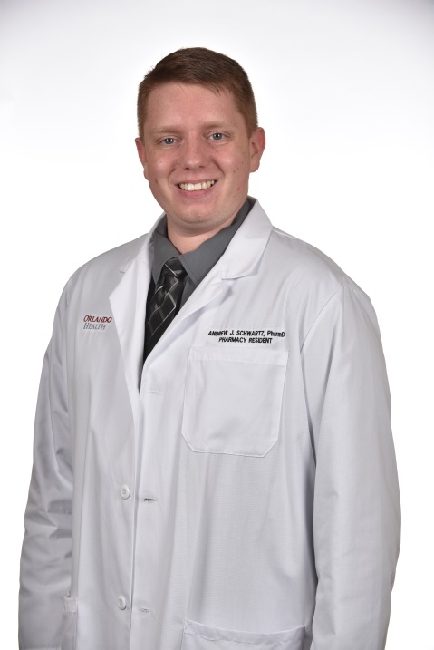
Andrew Schwartz, Pharm.D.
Dr. Andrew Schwartz, from Tampa, FL, received his Bachelors of Science in Microbiology in 2013 and his Doctor of Pharmacy degree in 2017 from the University of South Florida. As a PGY-1 pharmacy resident at Orlando Heath, Dr. Schwartz will participate in patient care rounds and monthly code coverage. He will complete a research project evaluating a pharmacist’s impact on sedation weaning in trauma patients, conduct a MUE reviewing the utilization of clevidipine, and present a continuing-education seminar on the causes and management of drug shortages in the healthcare system. Upon completion of his residency, Dr. Schwartz plans to continue his education with a PGY-2 pharmacy residency in critical care.

Email: Andrew.Schwartz@orlandohealth.com

Jesse Unum, Pharm.D.
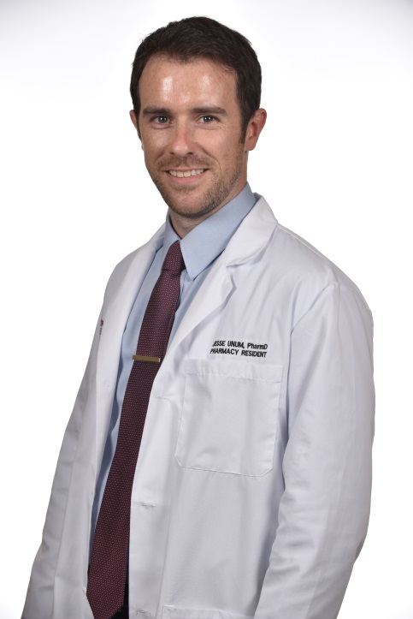
Dr. Jesse Unum, from Melbourne, FL, received his Doctor of Pharmacy from the University Of Florida College Of Pharmacy’s Orlando Campus in 2017. As a PGY-1 resident, Dr. Unum will participate in patient-care rounds and monthly code coverage. He will complete a research project evaluating the use of parenteral iron products in iron deficiency anemia in pregnancy, perform an MUE looking at tranexamic acid use in orthopedic procedures at ORMC, and present a continuing-education seminar on beta-lactam allergy cross-reactivity. Upon completion of his residency, he plans to pursue a PGY-2 pharmacy residency and a career in clinical pharmacy with a focus in hematology/oncology, or infectious disease.

Email: Jesse.Unum@orlandohealth.com
PGY-2 Critical Care Pharmacy Residents
Dominick Curry, Pharm.D.
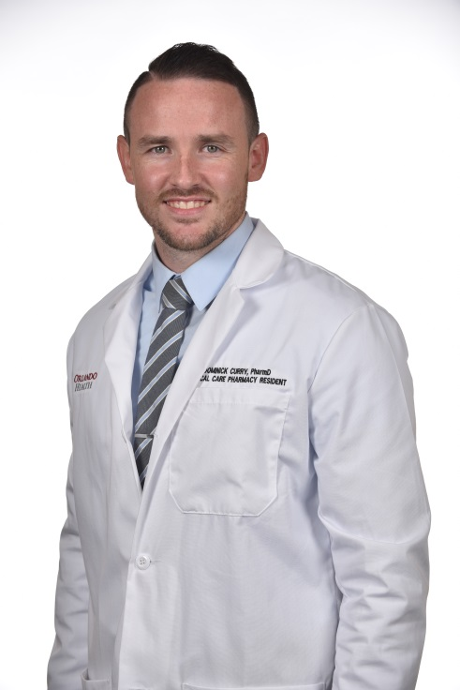
Dr. Dominick Curry, from Indianapolis, IN, received his Doctor of Pharmacy from the University Of Florida College Of Pharmacy (Orlando Campus) in May 2016 and completed his PGY-1 residency at Orlando Health in 2017. During his PGY-2 Critical Care residency at Orlando Health, Dr. Curry will participate in patient-care rounds and weekly code coverage. He will complete a research project evaluating the use of 23.4% hypertonic saline for the management of intracranial hypertension, perform an MUE evaluating the use of vasopressin, and present a continuing-education seminar on the role of albumin. Upon completion of his residency, he plans to pursue a career as a clinical specialist in the critical care or emergency medicine setting.

Email: Dominick.Curry@orlandohealth.com

Becca Toor, Pharm.D.
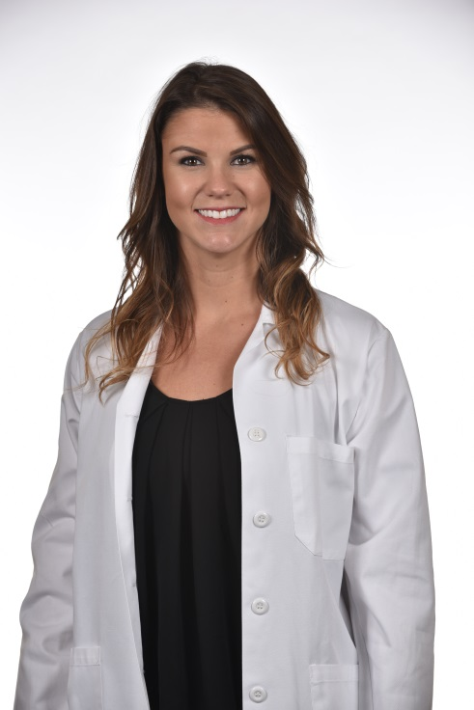
Dr. Becca Toor, from Englewood, FL, received her her Doctor of Pharmacy Degree from LECOM School of Pharmacy in Bradenton Florida in 2016 and completed her PGY-1 residency at Orlando Health in 2017. During her PGY-2 Critical Care residency at Orlando Health, Dr. Toor will participate in patient-care rounds and monthly code coverage. She will also complete a research project focusing on the use of valproic acid versus Seroquel in ICU delirium, complete an MUE assessing the use of aztreonam and present a continuing-education seminar reviewing fibrinolytic therapy in acute pulmonary embolism. After completing her residency, she plans to pursue a career as a clinical specialist in the critical care setting.

Email: Rebecca.Toor@orlandohealth.com

PGY-2 Emergency Medicine Pharmacy Resident
Bailey Constantine, Pharm.D.
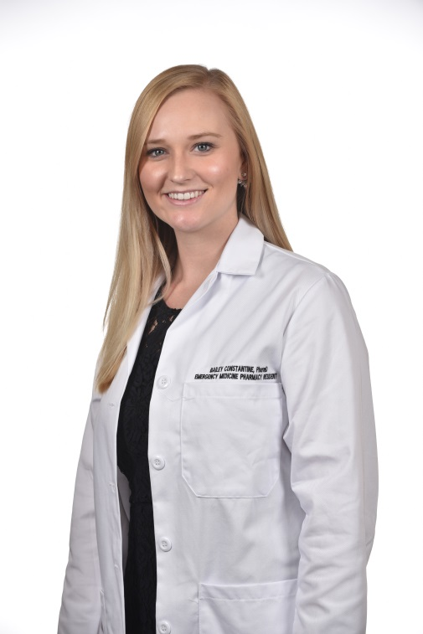
Dr. Bailey Constantine, originally from Jeffersonville, IN, received her Doctor of Pharmacy degree from Purdue University in 2016 and completed her PGY-1 pharmacy residency at Orlando Health in 2017. During her PGY-2 Emergency Medicine residency at Orlando Health, Dr. Constantine will participate in Advanced Trauma Life Support classes and monthly code coverage. She will also complete a research project focusing on the use of oxytocin for the prevention in postpartum hemorrhage, complete an MUE assessing the use of tetanus toxoid containing vaccines, and present a continuing-education seminar reviewing emergency preparedness and mass casualty incidents. After completing her residency, she plans to pursue a career as a clinical specialist in emergency medicine.

Email: Bailey.Constantine@orlandohealth.com
PGY-2 Pediatric Pharmacy Resident
Haley Grunwald, Pharm.D.
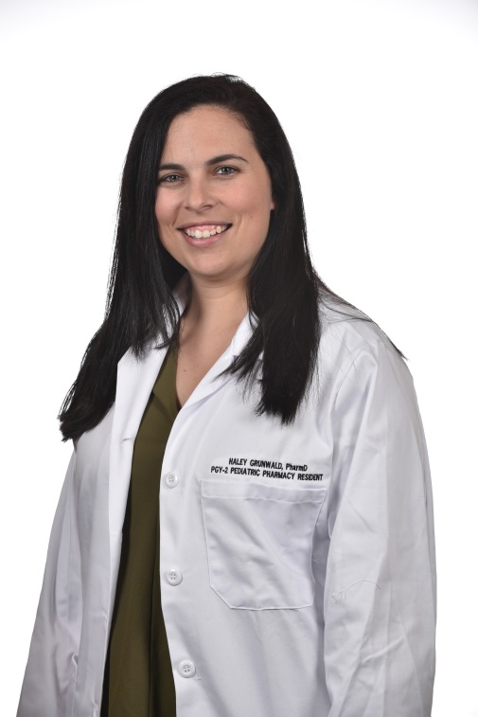
Dr. Haley Grunwald, from Boca Raton, FL, received her Bachelors of Science in Biochemistry in 2012, followed by her Doctor of Pharmacy degree from the University of Florida in 2016. She completed her PGY-1 Pharmacy Practice Residency at Johns Hopkins All Children’s Hospital in St. Petersburg Florida. During her PGY-2 Pediatric Residency at Arnold Palmer Hospital, Dr. Grunwald will participate in patient care rounds, complete a research project on the evaluation of the efficacy and safety of diazoxide for the treatment of neonatal hypoglycemia, present a continuing education seminar on the use of anthithrombin III in pediatric patients, and conduct a medication use evaluation looking at the efficacy and use of a pediatric aminoglycoside dosing protocol. Following completion of her residency, Dr. Grunwald plans to pursue a career in pediatric clinical pharmacy.

Email: Haley.grunwald@orlandohealth.com

PGY-2 Oncology Pharmacy Resident
Natalie Giron, Pharm.D.
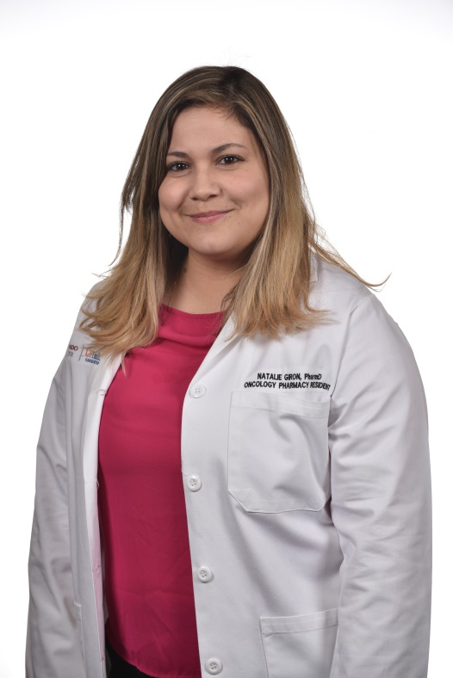
Dr. Natalie Giron is originally from the Naples and Orlando, FL region and received her Doctor of Pharmacy degree from Mercer University College of Pharmacy in 2016. She completed her PGY-1 pharmacy practice residency at The University of Pittsburgh Medical Center in 2016. During her PGY-2 Oncology residency at the Orlando Health UF Health Cancer Center, she will participate in inpatient, outpatient, and research endeavors at the cancer center. Her research project is focused on the incidence of persistent proteinuria in patients who are currently on bevacizumab for gynecologic malignancies. She will also complete an MUE on IVIG use in oncology patients and is currently preparing a monograph for Vyxeos, the new liposomal formulation of the first line treatment “7+3” in acute myeloid leukemia patients. She will present a continuous education seminar focusing on the recent updates in the treatment of Multiple Myeloma. Following completion of her residency, Dr. Giron plans to pursue a career as a clinical pharmacy specialist in oncology.

Email: Natalie.Giron@orlandohealth.com

