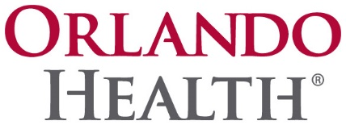

2021 UPCOMING CONSTRUCTION PROJECTS

Orlando Health Orlando Regional Medical Center Interventional Endoscopy Institute project.

Orlando Health Downtown East Central Energy Plant project.

Orlando Health Reunion Village free standing ER-CPPI is now bidding.

Orlando Health St. Cloud Hospital Patient floor finish upgrades project.

Bayfront Health St. Petersburg Hospital Room, Lobby and Corridor upgrades project.

Orlando Health Orlando Regional Medical Center Surgical expansion including 10 new ORs Pre-Post and PACU project.

Orlando Health Cancer Institute Bone Marrow Transplant fit out including new Pharmacy and Infusion.

Orlando Health St. Cloud Hospital and Oviedo have numerous Physician suite fit outs coming in January.

Orlando Health South Lake Hospital New Bed Tower-CM selections is in the final phase and then will move to bidding and sub communication.

Please download the Supplier - Company Profile Form, print and complete your business introduction page. Then, add relevant attachments and send to R-SupplierRequest@orlandohealth.com.

